zone "vm.local" {

type master;

file "/etc/bind/vm/vm.local";

};





zone "0.168.192.in-addr.arpa" {

type master;

file "/etc/bind/vm/0.168.192.in-addr.arpa";

};





;

; BIND data file for local loopback interface

;

$TTL 604800

@ IN SOA vm.local. root.vm.local. (

2 ; Serial

604800 ; Refresh

86400 ; Retry

2419200 ; Expire

604800 ) ; Negative Cache TTL

;

0.168.192.in-addr.arpa. IN NS vm.local.

100 IN PTR vm.local.

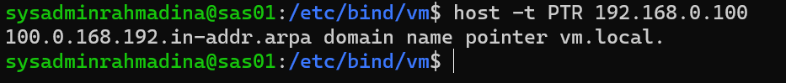

options {

directory "/var/cache/bind";

// If there is a firewall between you and nameservers > // to talk to, you may need to fix the firewall to all> // ports to talk. See http://www.kb.cert.org/vuls/id/>

// If your ISP provided one or more IP addresses for s> // nameservers, you probably want to use them as forwa> // Uncomment the following block, and insert the addre> // the all-0's placeholder.

forwarders {

8.8.8.8;

};

//====================================================>

// If BIND logs error messages about the root key bein>

// you will need to update your keys. See https://www>

//====================================================>

//dnssec-validation auto;

allow-query{any;};

listen-on-v6 { any; };

};

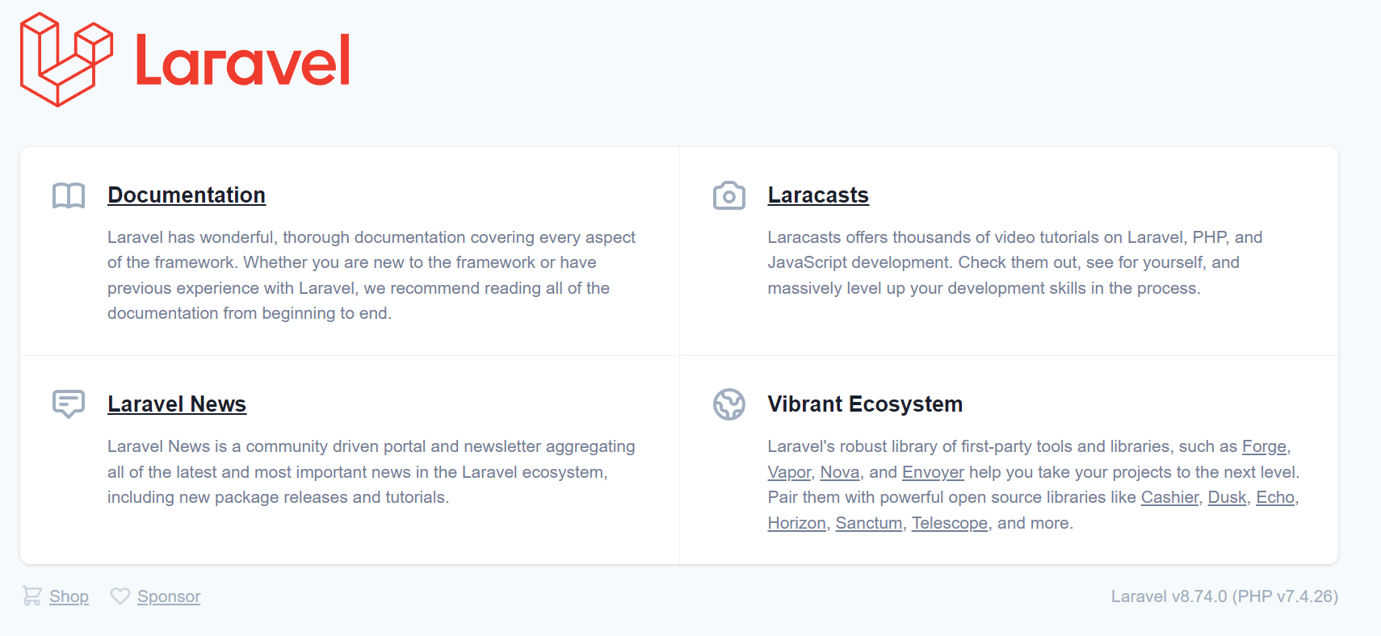

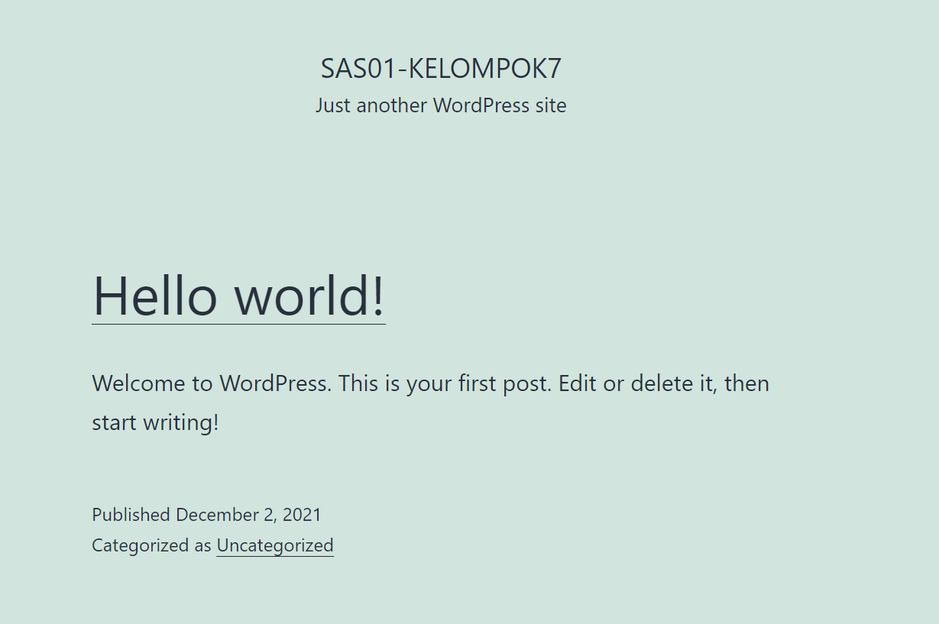

Prak modul 3

Isi lv/tasks/main.yml :

|  |
| --- |
| ---  - name: delete apt chache  become: yes  become_user: root  become_method: su  command: rm -vf /var/lib/apt/lists/*  - name: install package tambahan  become: yes  become_user: root  become_method: su  apt: name={{ item }} state=latest update_cache=true  with_items:  - gtkhash  - bind9  - dnsutils  - crack-md5  - git  - curl  - name: buat directori dev/landing  file:  path: /var/www/html/dev/landing  state: directory  - name: copy named.conf.local  template:  src=templates/named.conf.local  dest=/var/www/html/dev/landing  notify:  - restart bind  - name: copy vm.local  template:  src=templates/vm.local  dest=/var/www/html/dev/landing  notify:  - restart bind  - name: copy 0.168.192.in-addr.arpa  template:  src=templates/0.168.192.in-addr.arpa  dest=/var/www/html/dev/landing  notify:  - restart bind  - name: copy resolv.conf  template:  src=templates/resolv.conf  dest=/etc/resolv.conf  - name: copy named.conf.options  template:  src=templates/named.conf.options  dest=/var/www/html/dev/landing  notify:  - restart bind |

Isi lv/handlers/main.yml

|  |
| --- |
| ---  - name: restart nginx  become: yes  become_user: root  become_method: su  action: service name=nginx state=restarted  - name: restart php  become: yes  become_user: root  become_method: su  action: service name=php7.4-fpm state=restarted  - name: restart bind  become: yes  become_user: root  become_method: su  action: service name=bind9 state=restarted |

Pada lv/templates/named.conf.local

|  |
| --- |
| //  // Do any local configuration here  //  // Consider adding the 1918 zones here, if they are not used in your  // organization  //include "/etc/bind/zones.rfc1918";  zone "vm.local" {  type master;  file "/etc/bind/vm/vm.local";  };  zone "0.168.192.in-addr.arpa" {  type master;  file "/etc/bind/vm/0.168.192.in-addr.arpa";  }; |

Isi lv/templates/vm.local

|  |
| --- |
| ;  ; BIND data file for local loopback interface  ;  $TTL 604800  @ IN SOA vm.local. root.vm.local. (  2 ; Serial  604800 ; Refresh  86400 ; Retry  2419200 ; Expire  604800 ) ; Negative Cache TTL  ;  @ IN NS vm.local.  @ IN A 192.168.0.100  dev IN CNAME vm.local. |

Isi lv/template/ 0.168.192.in-addr.arpa

|  |
| --- |
| ;  ; BIND data file for local loopback interface  ;  $TTL 604800  @ IN SOA vm.local. root.vm.local. (  2 ; Serial  604800 ; Refresh  86400 ; Retry  2419200 ; Expire  604800 ) ; Negative Cache TTL  ;  0.168.192.in-addr.arpa. IN NS vm.local. ; IP VM dibalik tanpa byte ke 4  100 IN PTR vm.local. ; byte ke 4 IP VM |

Isi lv/templates/resolv.conf

|  |
| --- |
| # This file is managed by man:systemd-resolved(8). Do not edit.  #  # This is a dynamic resolv.conf file for connecting local clients to the  # internal DNS stub resolver of systemd-resolved. This file lists all  # configured search domains.  #  # Run "resolvectl status" to see details about the uplink DNS servers  # currently in use.  #  # Third party programs must not access this file directly, but only through the  # symlink at /etc/resolv.conf. To manage man:resolv.conf(5) in a different way,  # replace this symlink by a static file or a different symlink.  #  # See man:systemd-resolved.service(8) for details about the supported modes of  # operation for /etc/resolv.conf.  #nameserver 127.0.0.53  #options edns0 trust-ad  nameserver 192.168.0.100 |

Isi lv/templates/named.conf.options

|  |
| --- |
| options {  directory "/var/cache/bind";  // If there is a firewall between you and nameservers you want  // to talk to, you may need to fix the firewall to allow multiple  // ports to talk. See http://www.kb.cert.org/vuls/id/800113  // If your ISP provided one or more IP addresses for stable  // nameservers, you probably want to use them as forwarders.  // Uncomment the following block, and insert the addresses replacing  // the all-0's placeholder.  forwarders {  8.8.8.8;  };  //========================================================================  // If BIND logs error messages about the root key being expired,  // you will need to update your keys. See https://www.isc.org/bind-keys  //========================================================================  //dnssec-validation auto;  allow-query{any;};  listen-on-v6 { any; };  }; |

Jalankan ansible-playbook -i hosts setting-landing.yml -k

Masuk /etc/hosts

Tambahkan dev.vm.local



Masuk /var/www/html/dev/landing pada lxc_landing

Edit vm.local



Lalu restart service bind9



Edit vm.local di sites available

Restart nginx -t dan -s reload

Ganti dns di control panel

Hasil

